**APPENDIX**

1: Sprint Report………………………………………………………….2

2: Project Summary……………………………………………………..3

3: Core concepts used in the project……………………………4

3: Algorithm………………………………………………………………..5

4: Flow diagram ………………………………………………………….6

5: Conclusion………………………………………………………………..7

6: Output Screenshots………………………………………………….10

7:GitHub linK

**PROJECT: COMPLAINT REDRESSEL SYSTEM**

**DONE BY: SHINY THAYIL VANI**

**SPRINT REPORT**

This project is planned in two sprint.

Sprint 1

|  |  |
| --- | --- |
| Task | Status |
| Creating flow of application for User | Achieved |
| Coding for the program | Achieved |
| Testing of the program | Achieved |

Sprint 2

|  |  |
| --- | --- |
| Task | Status |
| Creating flowchart for Admin | Achieved |
| Coding for the program | Achieved |
| Testing of the program | Achieved |
| Preparing Specification documents | Achieved |
| Creating GIT Repository | Achieved |
| Pushing the code and documents to GIT | Achieved |

**PROJECT SUMMARY**

This project is for addressing user complaints where the user can register their complaints as tickets.It has four modules:Admin,Manager,Engineer and User

The admin part of the application has access to the entire application.He can View the tickets.He can create,update and delete employee details.

The manager part of the application can view the tickets and assign it to the concerned employee/engineer.He can view the customer feedback also.

The engineer part of the application can view the tickets assigned to him,their status and also he can re-assign the tickets to other suitable employee.

The user can login with his/her credentials and view the previous tickets raised,their status and also raise a new ticket.

**CORE CONCEPTS USED**

Front end-HTML5,Bootstrap

Backend: Servlet,jsp

Db:MySql

FLOWCHART

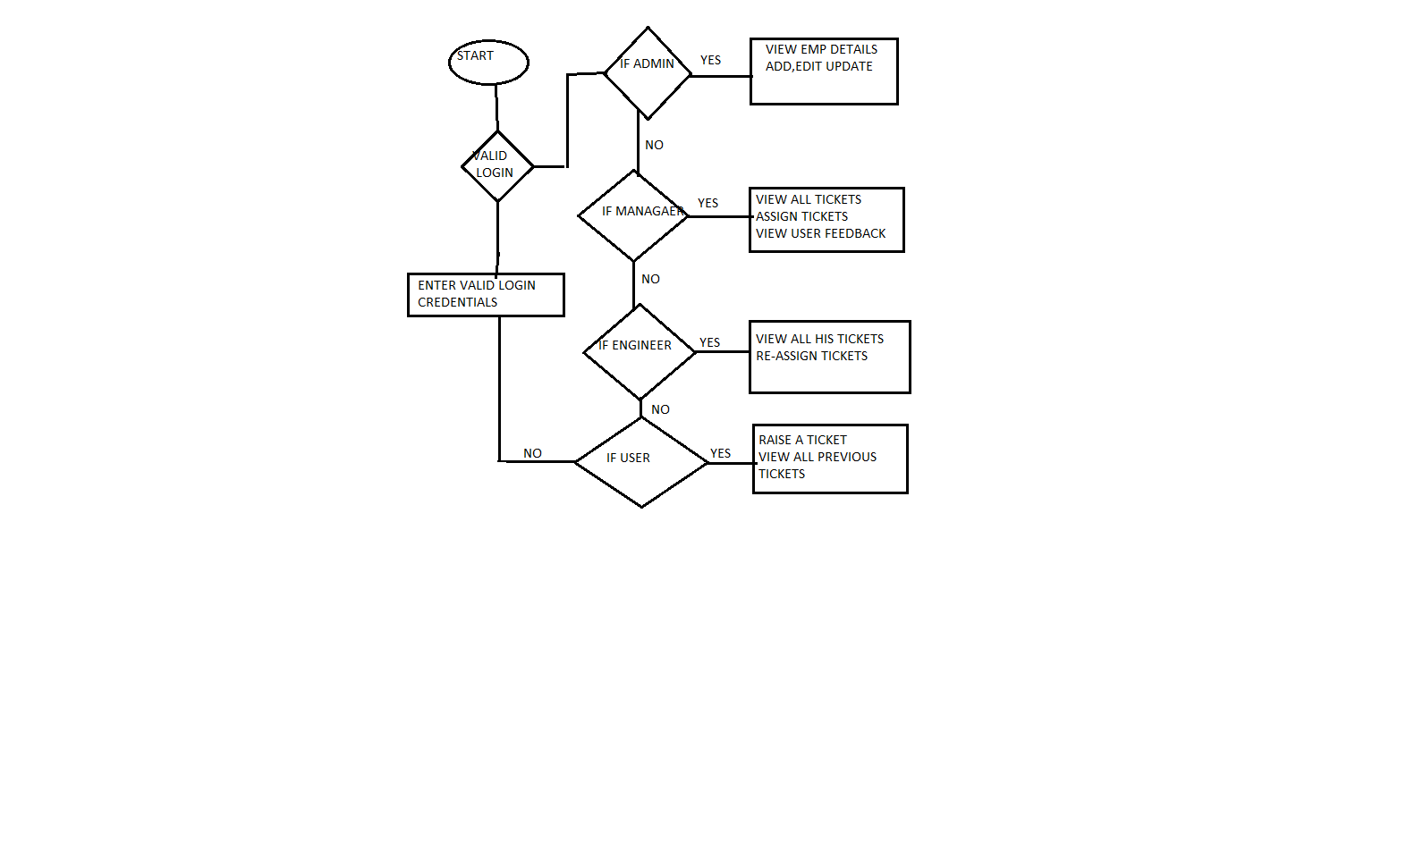

**Conclusion**: The application is user friendly and it can be further extended by adding other functionalities .

Output Screens

ADMIN SCREEN

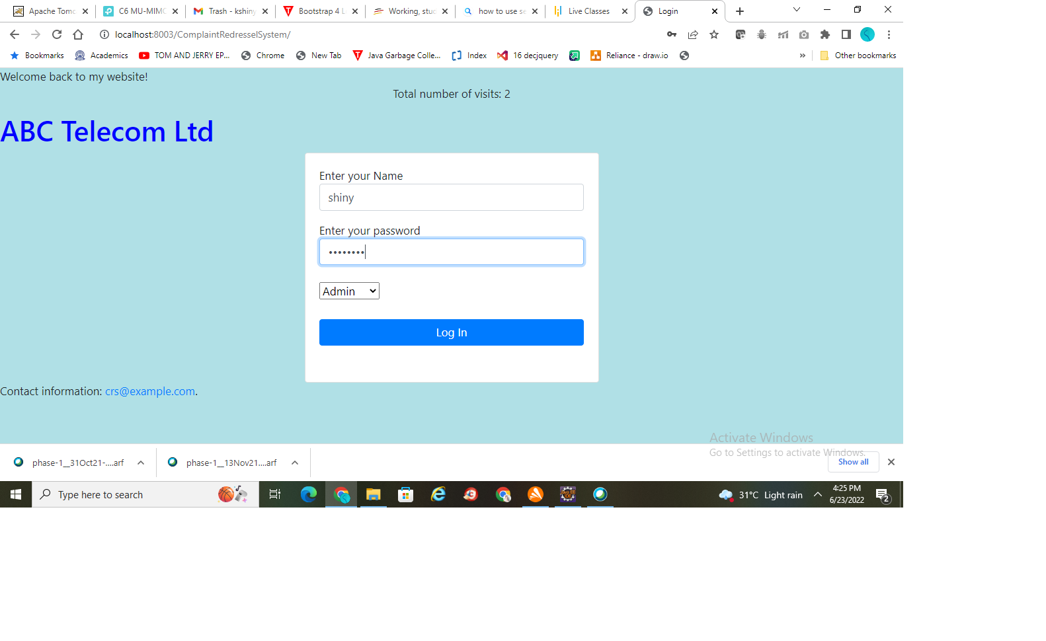

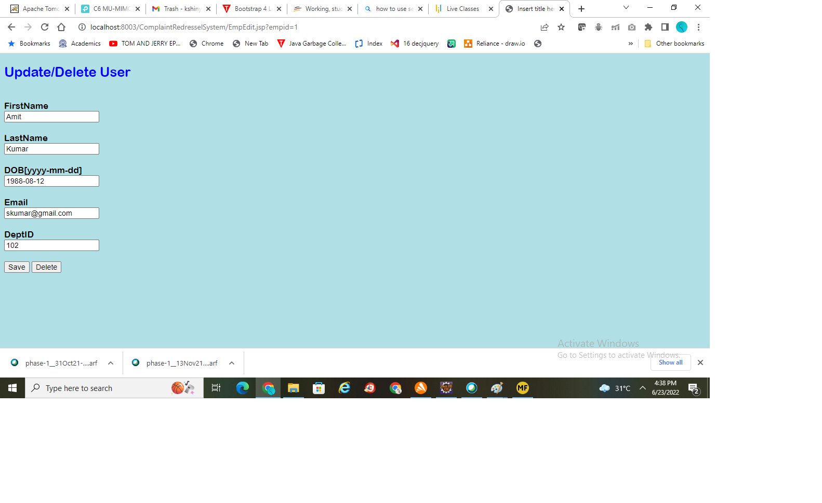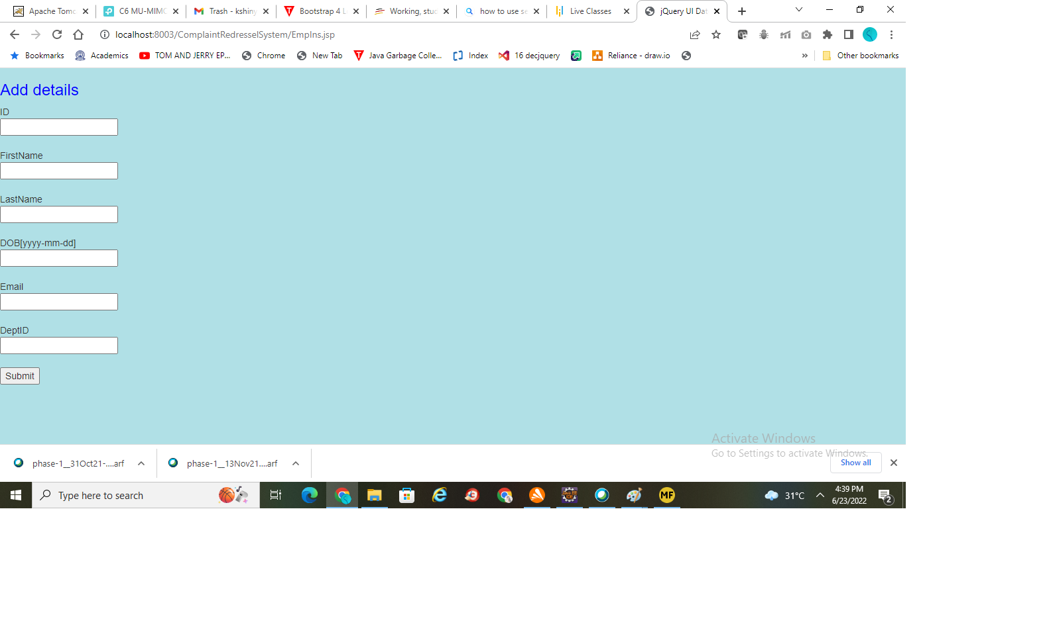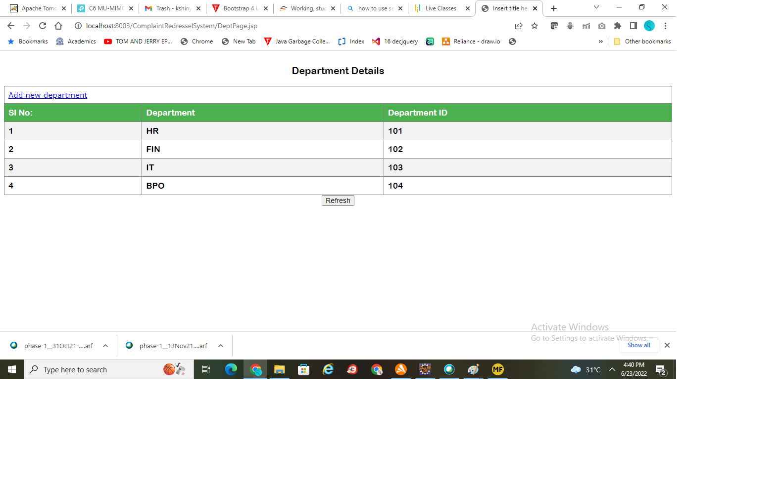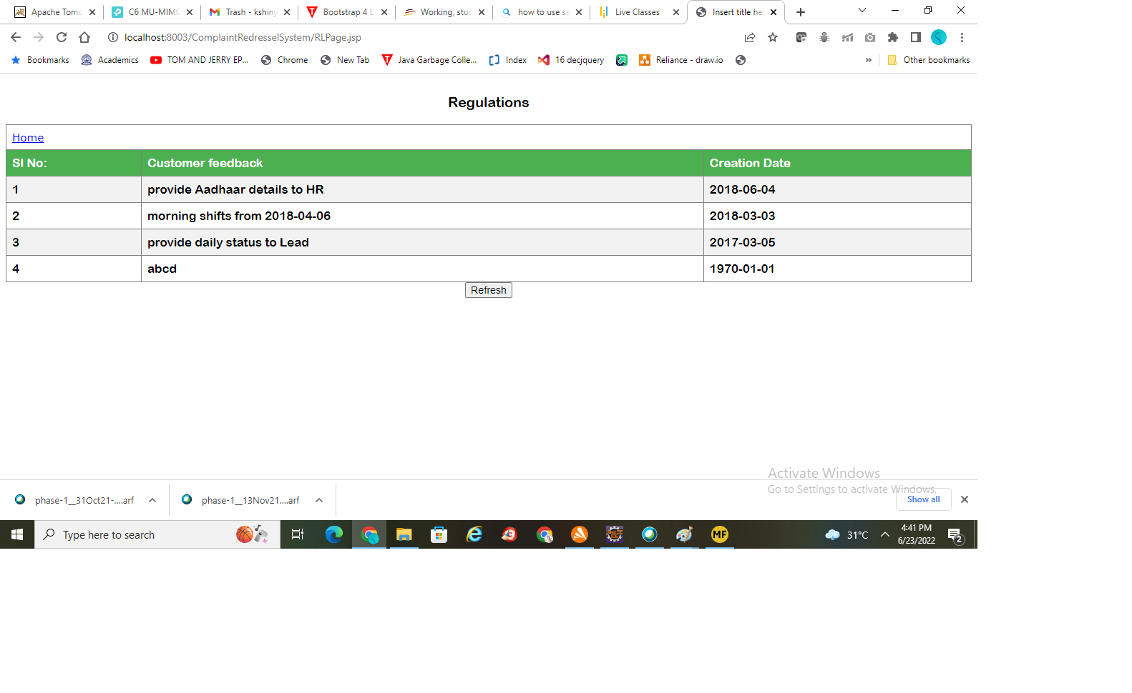

MANAGER OPTION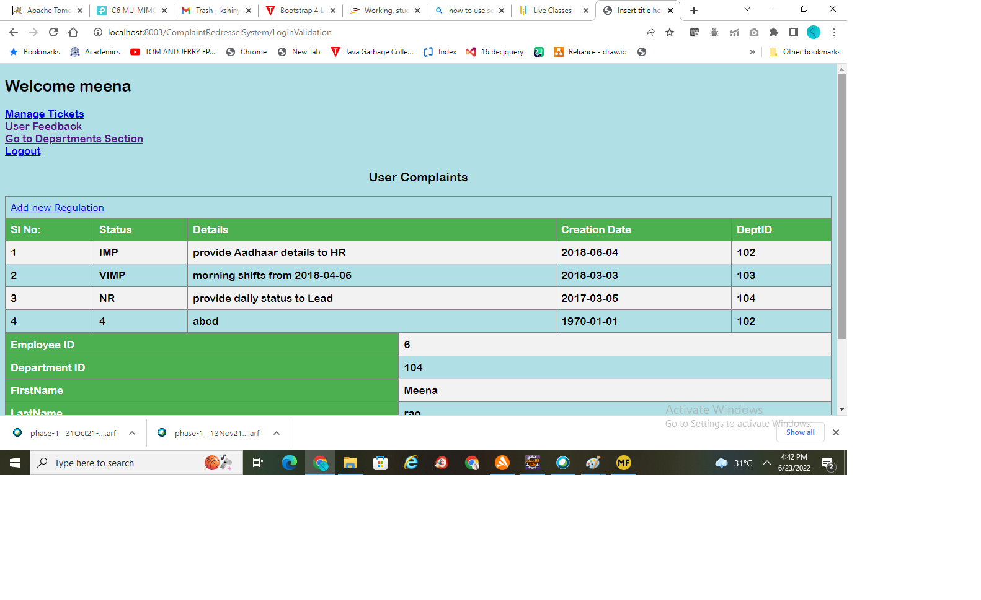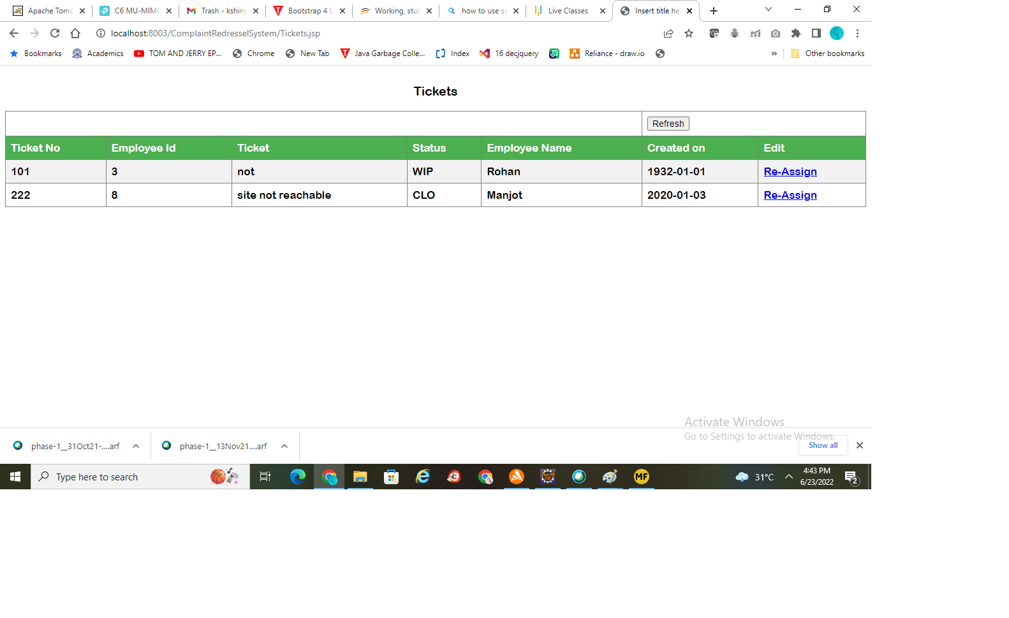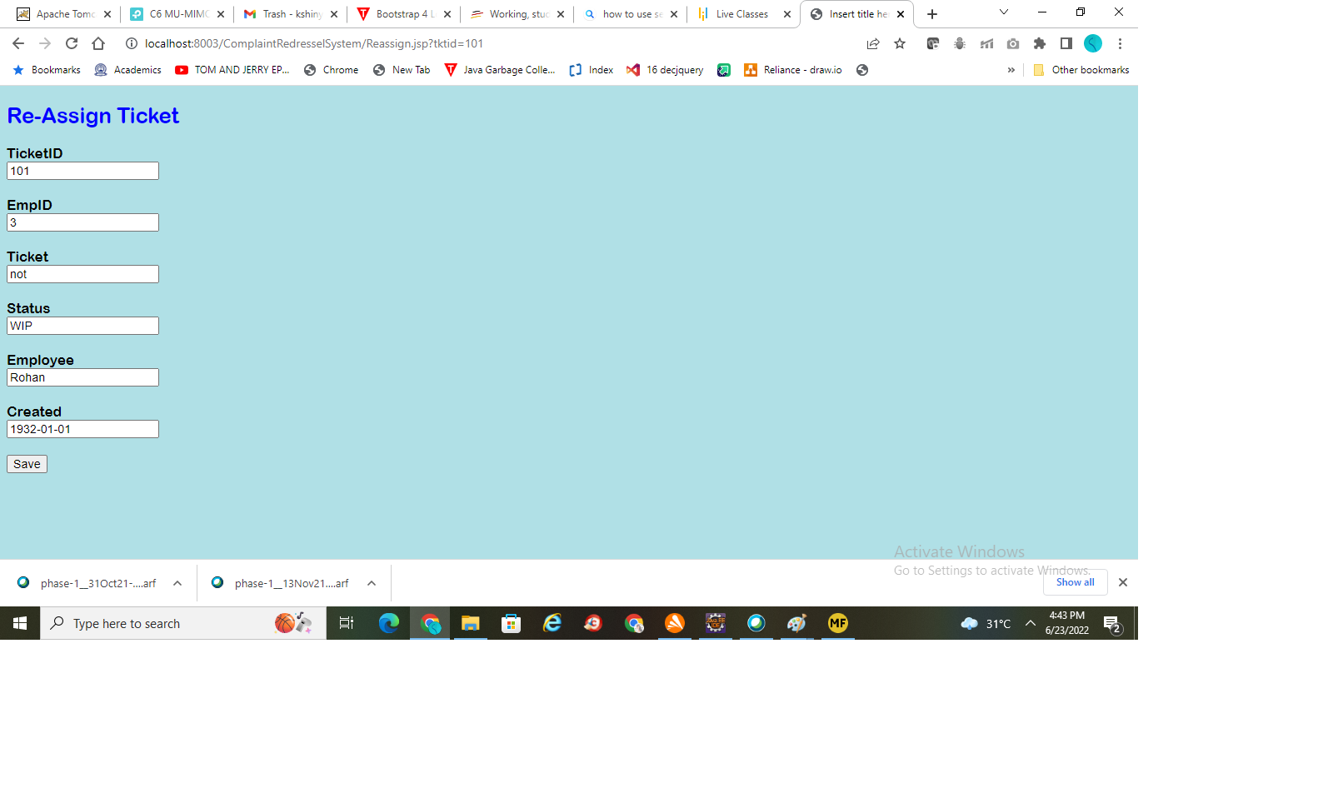

ENGINEER

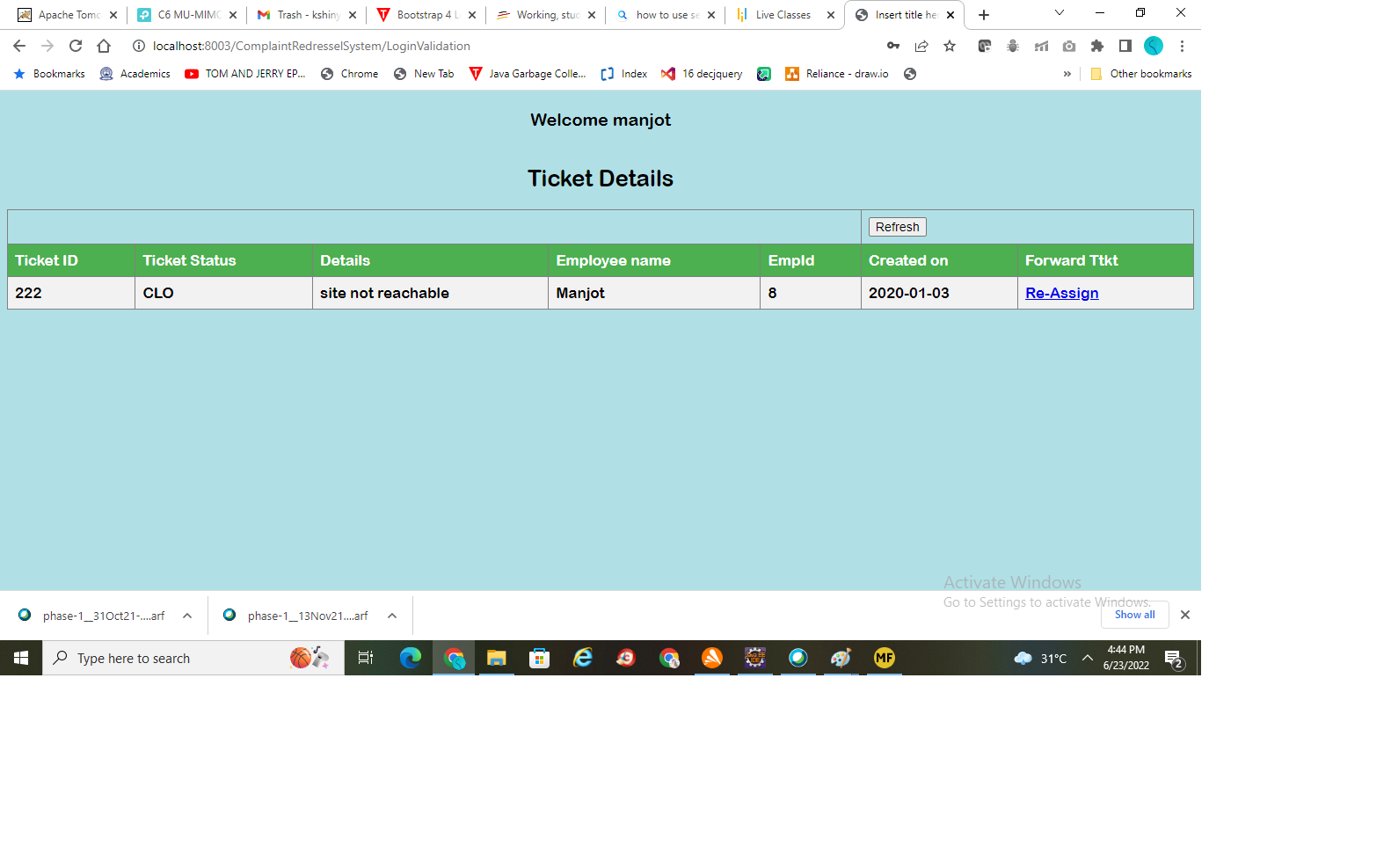



USER

